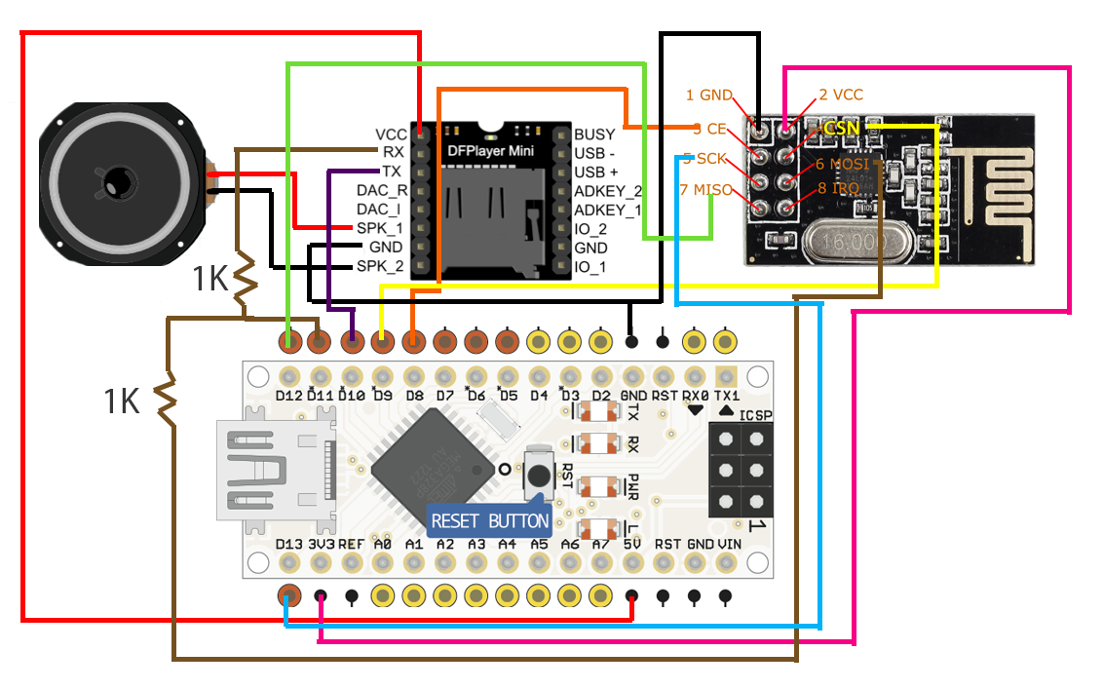
Created by Unlicensed Version
Created by Unlicensed Version
Created by Unlicensed Version
Created by Unlicensed Version
Created by Unlicensed Version
Created by Unlicensed Version
Created by Unlicensed Version
Created by Unlicensed Version
Created by Unlicensed Version

